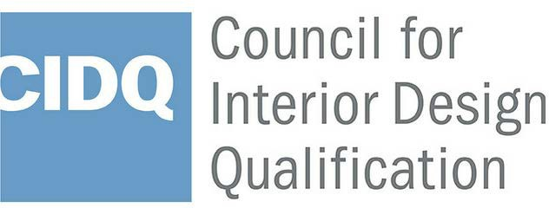
NAME CHANGE FORM

To request a name change to your NCIDQ Certificate and MyNCIDQ Profile, complete this form, and submit it with a copy of one (1) valid government-issued photo identification that clearly shows your current full name. Examples of acceptable forms of ID include driver’s license or passport. Email this form and supporting documentation to inquiries@cidq.org.
Be reminded that if you have a scheduled exam appointment you must request a name change no later than 3 business days prior to your scheduled appointment date for CIDQ to process your request in a timely fashion.
NAME & CONTACT INFORMATION

CURRENT FULL NAME

PREVIOUS FULL NAME

NCIDQ CERTIFICATION NUMBER OR EXAM CONTROL NUMBER

PRIMARY STREET ADDRESS

CITY STATE/PROVINCE

ZIP - POSTAL CODE PHONE NUMBER

EMAIL ADDRESS

IDENTIFICATION

Attach a copy of ONE valid government-issued photo identification (i.e., driver’s license, passport) showing CURRENT FULL NAME. Please ensure the ID is legible when copied.

AGREEMENT

By signing below, I verify that my name has changed to the “Current” full name above. I understand that all CIDQ correspondence will show my current name only. If my information changes in the future I will contact CIDQ to update.
Signature Date

CIDQ 225 REINEKERS LANE #210 ALEXANDRIA VA 22314 inquiries@cidq.org 202-731-0220 cidq.org

